US Accidents Analysis

**2019 – 2020**

A Project by

Kevin,Tamasree,Lekshmi &Hima

Introduction:

Road accidents have become very common these days. Nearly 1.25**million**people die in road crashes each year, on average,**3,287** deaths a day. Moreover, **20–50 million** people are injured or disabled annually.

Objective of the Analysis:

* Which **states** and **cities** of the 4 have most traffic accidents
* What is the **time of the day**, the **day of the wee**k and **the month** with the higher number of accidents?
* How many accidents over the **two** years?
* What are the most common weather conditions on the days of the accidents?
* How many accidents have a severity level of 1, 2, 3 and 4?

This analysis can be used by authorities to study car accidents hotspot locations and prevent accidents in the future by taking some preventive measures.

About the Data:

We acquired data from Kaggle. This is a country wide car accident dataset which covers 49 states of the USA. The data are collected from 2016 to 2020. There are about 1.5 million accident records in this dataset. However our team concentrated on the data of past 2 years and select cities due to huge volume

US Traffic Accidents Data Analysis for the year 2019 – 2020

Cities Selected : New York,Dallas (TX),Los Angeles, San Diego (CA)

Source : <https://www.kaggle.com/sobhanmoosavi/us-accidents>

**Work flow of the Project.**

We used the following workflow to create our final web page.

**Field description:**

* **Cleaned Dataframe after ETL**

* **FLASK – API route generation**

* **JSON Response**

**Radar chart & D3 Plots**

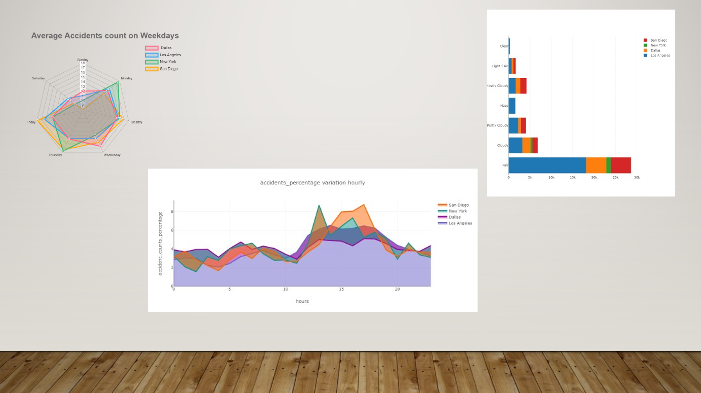

**Heat map using leaflet.js**

**Home page**

**Findings & Conclusion**

After the analysis, we found the following:

* LA top the charts.!
* Mondays and Fridays between 12 to 6pm has most count. December has seen highest rate.
* Surprisingly 2020 tops the charts, considering it was the pandemic year with lockdown.
* Most accidents were caused on a moderately fair day. Also, most accidents happened at junction and traffic signals.
* Most Accidents have severity level -2 which means there were minor injuries, 4 being the fatal.